Katheryn Sullivan

Gonzales

September 2014 

When I was 12, my best friend and I would walk to Walgreens to get nail polish, or so our moms thought. Little did they know, we were satisfying our preteen fantasies with what some women refer to as the bible. What used to be a figure of our imaginations became a tangible object in our rebellious hands. In 2007, I had no idea what rhetoric was or how at such an innocent age, Cosmopolitan was already spinning its wheels in my brain. Was it the vibrant combination of sun-yellow with a peony pink backsplash that made us rebel? Or could it have been the seemingly perfect image of Kate Upton splashed on the cover, in all of her glory and sex appeal that drew us in? As 12 year olds with braces and budding breasts, I think we were simply yearning for some hope and normalcy, which for $3.99 Cosmo graciously gave us every month.

Eight years later and I still not-so-patiently wait every month for the next issue, except now I have a subscription that was somewhat willingly granted to me by my mother on my 17th Birthday. Within those eight years I’ve also discovered the various forms that Cosmo takes place in during my daily life. I will be the first to say that I’m not excessively tech-savvy, despite my generations up and coming knowledge on gadgets. However, it’s fascinating to me that while I’m waiting for my monthly issues, I can find Joanna Cole, Cosmo Editor, on Twitter, Instagram, YouTube, and my personal favorite, Pinterest – it’s a revelation! Not only can I hear from Joanna on a regular basis, I can read columns from my favorite authors, read stories by normal girls, such as myself, review personal training tips, and even be given notes on daily recipes. To me, Cosmopolitan is somewhere very close to Heaven. When I was researching the history of the magazine, I found an article that really hit home with me on their website. The article is titled *How Cosmo Changed the World, The fascinating story of the magazine you know, love, and can’t live without*. Author of the piece, Jennifer Benjamin says, “If you’re like most of our readers, you can’t wait to tear into Cosmo every month, eager for tips on everything from having great sex to scoring your dream job. Oh, let’s just say it: Cosmo’s your bible!” Amen Jennifer. It’s fascinating that even before having read this article, I said something similar in the previous paragraph – they really do know everything.

‘60s girl, Helen Gurley Brown is the woman we have to thank for such magic. Since then, “Cosmo has not only become the number-one-selling monthly magazine on the newsstand, but it has also served as an agent for social change, encouraging women everything to go after what they want (whether it be in the boardroom or the bedroom.)” Based on these points alone, Helen was already appealing to her audience through what the Greeks define as pathos, the appealing to feeling. Speaking for myself, if you connect to me on a feelings level, I will most likely love you. Knowing this, Helen grabbed the Greek ideals by the horns and started appealing like crazy, eventually leading to what we have today.

Cosmopolitan magazine appeals to all women everywhere. With publications that are world-wide and smart-phones that make it possible for us to catch up at any time, escaping to our bible at any moment has never been so easy. Cosmopolitan has magazines in Britain, India, and even Africa. Needless to say, the magazine has a mission of appealing to a variety of women. As women we vary in shapes, sizes, stories, interests, lives, looks, and desires. This magazine brings us together and celebrates the fact that we all share the commonality of being beautiful, powerful women. From the beginning of the magazine in the ‘60s where “young, single women were enjoying a new level of freedom,” a standard was set and that birth of a new type of woman was born. This publication marks the beginning of female revolution as we know it; “For the first time, they were beginning to bust their butts in formerly male-dominated fields and explore premarital sex,” topics that we know were largely off limits. Don’t be caught off guard, most women during this time were still not participating in conversations such as these in public, but they were definitely thoughts they had. The best thing Helen Gurley Brown did for us was she told “women they didn’t need a man to be happy,” while also openly talking about guilt-free sex. What a foreign concept during an era where women’s voting was the most scandalous topic of conversation. Cosmopolitan made it okay for women to be themselves, with all of their desires, fantasies, problems, and curiosities. Keeping those ideals at heart, each month, each news piece, and each headline is purposefully made to remind us how amazing such a feat is and how far we’ve come.

Right off the bat, Cosmo uses artifacts that are visually, emotionally, and mentally appealing. From the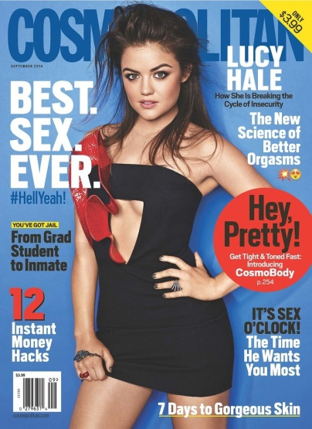 striking blue letters and comparative blue background, we’re drawn in. The eye-catching red speech bubble that just so happens to go perfectly with the sash on Lucy’s dress doesn’t make it any easier to look away, especially with the compliment of calling us pretty. My eyes are immediately drawn to it and all of my attention immediately goes right to its place on the rack or I see it first in my stack of mail.

Speaking directly about the woman on the cover, Lucy Hale, we know that she’s clearly attractive and that she’s clearly an icon. These are both things that women either pride themselves on being or make it a constant thought to achieve goals similar to those of iconic women. The women that embody the image are women that we typically look up to. Even if we don’t know who Lucy is, we want to – everything about her draws us in. Lucy and the other cover items that surround her scream attraction, appeal, and desire – this is the stuff that sells and this is the stuff that women really care about – since the ‘60s remember? Brummett says in his book *Rhetoric in Popular Culture* that “the ways in which we are influenced through signs can be observed on this every day, minute-by-minute level of popular culture (Brummett 5).” An example of what Brummett is referring to can be seen right here, through the popular culture of magazines whose content is influenced by the public and what we want to read. In turn, we are influenced by the sexual, appealing, and sleek signs of attraction displayed by the magazine.

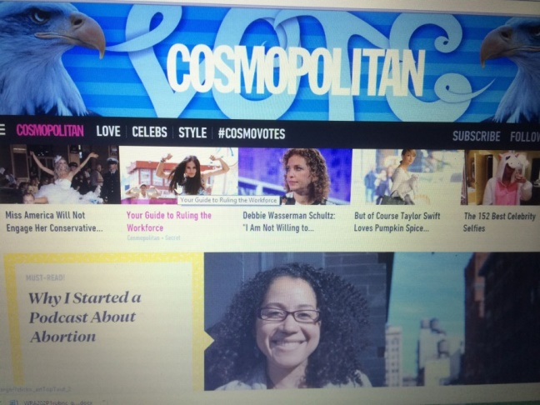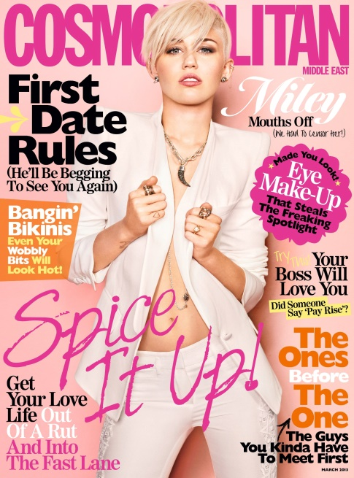

Another influential sign Cosmo has mastered is the significance of accessibility and relatability. Plastered across that top bar on their website is VOTE surrounded by an appealing blue, that’s crafted to be intriguing with different letters and two bald Eagles. I wonder if the general public knows how much one header says. Just from this I’ve gathered that they value Democracy and the freedom we have to vote, they are proud to be Americans, they are supporting the uniqueness and variety of being an American, and they are clearly in-tuned with not only social media and pop gossip, but with real-world political events. Brummett says, “Power is *the ability to control events and meanings* (5), which is something that the organizations of popular culture have seemed to grasp. Even here with one main website image, Cosmopolitan is showing that they have power over voting with the header and the tab #cosmovotes, they have control over social media with various links, images, and videos on their website, and they have power by putting the power in our hands to choose which medium we decide to explore through.

Similarly to the website homepage, this cover is another example of the relatability and variability Cosmo encompasses. Keep in mind, these are just the cover stories – there are pages and pages beyond what the cover displays that are intriguing to any woman. Just here we have dating advice, love advice, work advice, make-up advice, and some Miley Cyrus. Find any one random woman and I guarantee you she would be interested in at least one of those things. The genius in this is that Cosmo knows this. What sets this magazine apart from other magazines is that it brings in all areas of life: beauty, brains, sex, fashion, love, fitness, design, and most importantly, inspiration. Most effective is how the magazine talks about controversial topics tht up until very recently, were off limits. Even now, people (men and women included) cannot fathom the fact that there’s such a magazine that has a section solely devoted to sex. With sex being something all people has in common, the magazine freely acknowledges how natural it is, remembering it’s not something to be uncomfortable with. Having an outlet to freely source without that’s written by women just like us, talking about sex, experimenting with who we are, and reading about other women has never been so easy or comfortable. If you’re not into the sexual aspect, there are pages and pages of other news-worthy aspects of life. It’s appealing to know we have the ability to take part in this new era of women as well as knowing we have options to explore other interests within the same space.

In reference to variability is the ability of an organization to communicate through a variety of mediums. With all of the power they possess, Killingsworth, author of *A General Introduction to Rhetorical Appeals* discusses how they are comparable to the different paths that travelers who are using the sky as their guide can take. On page three of his text he says, “The ship goes from launch to landing, but the direction is guided by the stars.” Using the stars and the ship as a greater analogy to the author, the artifacts, the appeals, the medium, and the audience, a greater understanding of the formation of rhetoric is found. With Cosmopolitan magazine being the author and the ship, the various ways the magazine communicates is what guides us through the night sky. The website, the tangible magazine, Twitter, Instagram, Pinterest, and the color schemes chosen are how we choose to be guided, picking any path at any given time. With the appeals being the stars, the medium being the sky, and the audience, being women, Killingsworth opens this beautiful way of thinking about how rhetorical appeals work. When making a rhetorical appeal, such as, having relatable stories on a worldly known website, the audience has the ability to choose to read the story, follow that path of stars, or choose a different appeal, such as love tips, and follow that path of stars. Whichever path the ship or the audience chooses, the destination will be one that the author and sailor had previously mapped out.

A key component to a great company is how personalized and individual the customer is able to feel towards the products. The more personal the customer feels, the more likely they are going to choose your ship to board. With stories composed by our peers that take place in real life, we are bound to find something we can relate to on a personal level. Something that appealed to me earlier today as I was scrolling through my Pinterest feed is the image that’s displayed below. Now, this is simply an image but the story behind this image is what makes the organization so real. This woman below made a podcast about abortion – a real-life thing, a real-life issue, by a real life woman. What fascinates me about the publication is how extremely real it is. Yes, the stories by the hired columnists are awesome and I love them just as much as the next reading freak. But, it’s these stories about real women, by real women that really make the magazine stand out. Not to mention that I could find this article on their Instagram, in the magazine, and on the website as well. As being as busy as we are, they have made it easy for us to get our daily dose of “me time.” They know that at the end of a hard day, or even the middle of a good day, there is nothing more comforting than to read a well written story about a woman who is just like us. The designers of Cosmo take this information and use it to their advantage – they are fully aware of how to lure as in, they are the ones who get our wheels turning, and they have just the right tools to make us want to read these stories. With their use of emotion, relatability, and easy-access, more and more women are being drawn to this realistic publication.



When we think about rhetoric as the art that it is, its fascination can truly be seen. Every day we are surrounded by countless forms of rhetoric encompassed in the amazing symphony that we call life. Organizations produce rhetoric because rhetoric gets us thinking, it gets us attracted to artifacts that pull us in with their appeal. Whether that appeal is achieved emotionally, logically, or personally, the signs are there and as humans who believe in signs, we simply can’t ignore them. An important factor in the success of a public organization is how fluent their information reaches to multiple artifacts. In modern times, the magazine wouldn’t be charted number one as it is now without its multiple popular media outlets.

Essential to the production of such an organization as Cosmopolitan is the people who do the entire behind the scenes work. These are our columnists, the editor, the photographers, the assistants, and the publishers. Without these critical people and then some I did not mention, where would popular culture be? We wouldn’t know what it is or how to interpret it. That’s where professional writing comes into play – without which, this would be impossible. As professional writers, we create popular culture, we describe it, we analyze it, and we become it. Professional writing teaches us that there’s more to an article than a heading and some miscellaneous font. We learn how to influence people to see the things we want to see. We are the people who get hired to work for Cosmo – we are the people who change the world.

Bibliography

Brummett, Bary, “Rhetoric in Popular Culture” 2nd ed. The University of Texas at

Austin, USA: SAGE Publications, 2006. PDF.

Benjamin, Jennifer. "How Cosmo Changed the World." *Cosmopolitan*. Hearst Communications, Inc., 2 May 2007. Web. 23 Sept. 2014.

Killingsworth, “A General Introduction to Rhetorical Appeals.” Southern Illinois University Press: Carbondale, 2005. PDF